Lucas Swanson
10/1/2025
Programming Languages I
Reading 2
Exercise 1: Summarize
Backus-Naur Form (BNF) is a grammar used to define and construct a set of tokens and structure comprising the syntax of any language or to assist in defining a new one and will provide the productions in order to make parse trees.

Exercise 2: Demonstrate and Explain
Let’s take a specific example of the language C in BNF form and how one would read this. Our target shall be the following statement:
If (x > 0) x=x+1;
Statement Grammar:
<if-statement> : : = if <expression> then <statement> <else-part>
<else-part> : : = else <statement> | <empty>
<var-assignment> = <variable-name> = <variable-name> + <expression>
Expression Grammar:
<expression> : : = <expression> <comparator-operator> <expression>
<expression> : : = ( <expression> ) | <variable-name>
Statement Grammar:
<statement> : : = <variable-name> = <variable-name> <mathematical-operator> <variable-name>

Variable Name Grammar:
<variable-name> : : = <char> | <char> <variable-name>
<char> = a | b | … | z | A | B | … | Z | 0 | 1 | … | 9
Operator Grammar:
<comparator-operator> : : = > | < | >= | <= == | != |
<mathematical-operator> : : = + | - | * | /

To interpret these productions into a parse tree, we will have to combine all of the definitions from top to bottom until we build the targeted line of code. The easiest way to do this would be to break down the line of code into its basic parts, from the broadest level, to the narrowest. Let’s start with the statement itself. We have an if statement, where we are incrementing the variable x by one whenever x is greater than 0. We should start with an <if-statement> definition and continue to define all the pieces within the production for <if-statement> until we have filled every part with a variable, operator, or comparator as shown in the image below to build the total parse tree.
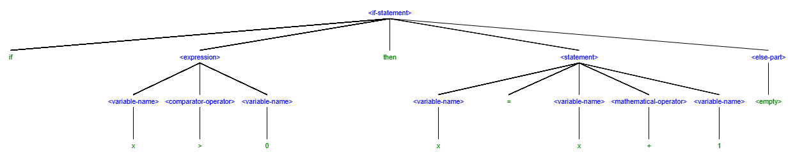

Exercise 3: Inquire
I have a hard time understanding how we are going to start assigning logical definitions to some of these built syntax trees. One of the flaws in my above definition of the syntax and structure behind a basic “IF” statement and incrementing a variable by a certain amount is that nowhere do we define what any of this does. When we interpret the BNF of some kind of structure or parses tree, how will we know what any of these operators or functions does on a logical level?

